# About the Hands-on Labs

This courseware includes a rich set of hands-on lab exercises that are designed to complement the learning material that is presented in the lectures. These lab exercises are designed to run in a cloud-based development environment with Microsoft Azure, Office 365 and SharePoint Online.

### GitHub Repository for this course

Student files for this course are maintained in a GitHub fil repository at <https://github.com/CriticalPathTraining/MSD365>.

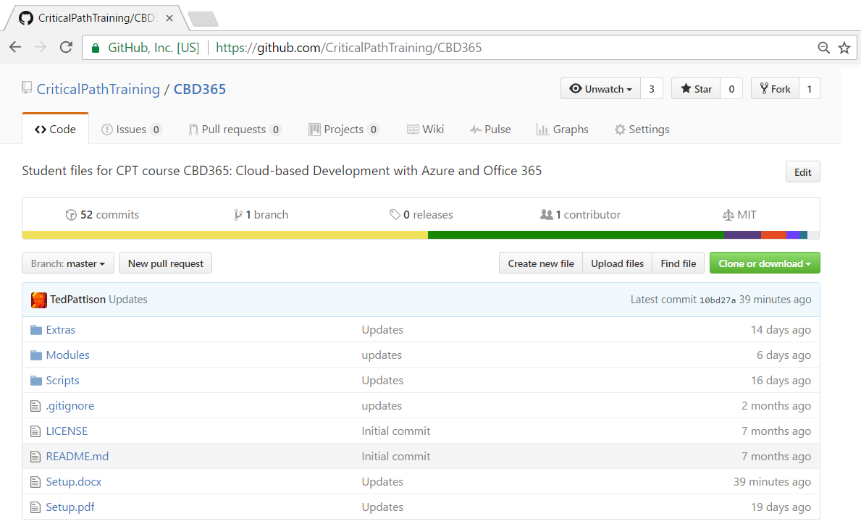

### Student Computer Setup for Lab Exercises

All lab exercises can be completed using a Windows PC running Windows 10 or Windows 8,1. All students must setup their Windows PC using the which begin on the next page of this student manual. You can also download the latest version of this setup guide in Microsoft Word (DOCX) or PDF format using the following links.

<https://github.com/CriticalPathTraining/MSD365/raw/master/Setup.docx>

<https://github.com/CriticalPathTraining/MSD365/raw/master/Setup.pdf>